Chapter 13, Solution 69.

In the circuit of Fig. 13.132, Z_{L} is adjusted until maximum average power is delivered to Z_{L}. Find Z_{L} and the maximum average power transferred to it. Take N₁ = 600 turns and N₂ = 200 turns.

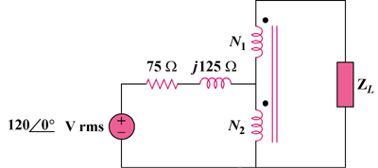

Figure 13.132
For Prob. 13.69.

Solution

We can find the Thevenin equivalent.

120∠0°

+
−

+

v₂

−

+

v₁

−

j125 Ω

N₁

N₂

+

V_{Th}

−

75 Ω

I₂

I₁

I₁ = I₂ = 0

As a step up transformer, v₁/v₂ = N₁/(N₁ + N₂) = 600/800 = 3/4

v₂ = 4v₁/3 = 4(120)/3 = 160∠0° rms = V_{Th}.

To find Z_{Th}, connect a 1-V source at the secondary terminals. We now have a step-down transformer.

1∠0° V

+
−

+

v₁

−

+

v₂

−

j125 Ω

75 Ω

I₁

I₂

v₁ = 1V, v₂ =I₂(75 + j125)

But v₁/v₂ = (N₁ + N₂)/N₁ = 800/200 which leads to v₁ = 4v₂ = 1

and v₂ = 0.25

I₁/I₂ = 200/800 = 1/4 which leads to I₂ = 4I₁

Hence 0.25 = 4I₁(75 + j125) or I₁ = 1/[16(75 + j125)

Z_{Th} = 1/I₁ = 16(75 + j125)

Therefore, Z_{L} = Z_{Th}* = (1.2 – j2) kΩ

Since V_{Th} is rms, p = (|V_{Th}|/2)²/R_{L} = (80)²/1200 = 5.333 watts

(1.2 – j2) kΩ, 5.333 W

